MEDIA ADVISORY

Media Contact: Carol Miller, carolmiller100@gmail.com, 202-306-0130
Public Inquiries: www.admoday.com
Editors: Advance photos and interviews are available on site or in studio

HISTORIC NEIGHBORHOOD HOSTS 40TH ANNIVERSARY ADAMS MORGAN DAY FESTIVAL
September 9, 2018, 12:00 p.m. to 6:00 p.m. EDT

Once again heralded by the Washington City Paper readers as one of the best neighborhood festivals,
Adams Morgan Day 2018 gears up to showcase its artistic and diverse culture and history

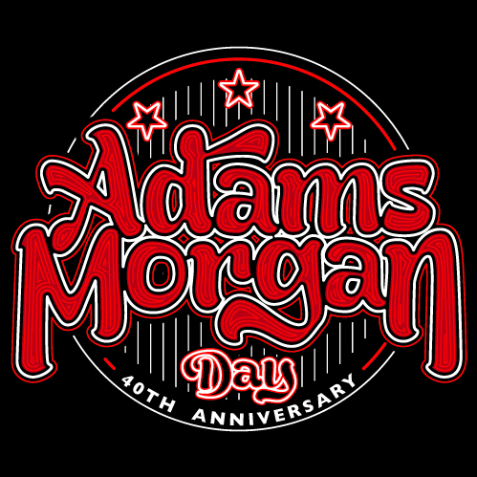
VISUALS: Adams Morgan Day 2018 will feature four decades of DC’s longest-running annual neighborhood festival, with two stages hosting a variety of live music and bands representative of the diverse cultures and generations living and working in the neighborhood
An historic crowdsourced Adams Morgan exhibition will be on display by DC Public Libraries and institutional partners.
Thanks to last year’s successful event, the number of vendors of unique art and locally-crafted goods has increased from 80 to more than 100, and Artists’ Alley will once again feature live visual art demos.
The entire festival is organized for all ages. A special section of the festival for youth and families will include games, performances, activities, and health and exercise programs at the newly renovated Marie H. Reed School and Community Center. Students will hold an arts and crafts sale and a bake sale supporting the after-school program. The youth and family area is made possible through a partnership with representatives of Volo City Kids Foundation and Marie Reed Elementary School Parent Teacher Organization.

Get a taste of Adams Morgan with the many food and beverage specials served by local restaurants and bars, ranging from street food and fine dining to a variety of international and American fare.

The community will enjoy many other surprises throughout the festival and welcomes neighbors from throughout the DC area to return to Adams Morgan Day, or check out the historic and updated neighborhood for the first time.

WHO: Community businesses, residents, artists, musicians and nonprofits are planning and hosting the 40th Annual Adams Morgan Day festival for residents and visitors.

WHAT:: The 40th Annual Adams Morgan Day, DC’s longest running neighborhood festival, will highlight the vibrant energy and diverse and creative cultures that define this historic neighborhood. As it has been since 2015, this year’s event is an all-volunteer, community-driven celebration for all ages. The event strives to strengthen community ties and economic development, and it thrives on sharing the elements that are so unique to Adams Morgan. To celebrate this historic anniversary the DC Public Library is developing partnerships within the community and with other area institutions to document the history of the festival and of the neighborhood itself. This effort is a celebration of Adams Morgan as a cultural crossroads through exhibiting crowdsourced photos, documents, and stories, as well as sponsoring a variety of musical performances.

WHEN: Sunday, September 9, 2018 from 12:00 p.m. to 6:00 p.m. EDT. Some businesses offer specials outside of those hours.

WHERE: Businesses, public spaces and the grounds of Marie H. Reed Elementary School and Community Center along the entire stretch of 18th Street and Columbia Road NW corridors of Adams Morgan, Washington DC; 18th Street NW will be closed to accommodate visitors and vendors from Columbia Road to Wyoming Avenue NW. A map of activities and details from participating businesses that log their activities will be available before the event, at www.admoday.com.

HOW: The neighborhood festival is made possible by thousands of volunteer hours, in-kind services and funds provided by committed Adams Morgan residents and businesses, individual donors and sponsors that serve Adams Morgan and the Washington DC area. The organizers put a high priority on fiscal transparency. More information, vendor applications and a log for businesses planning activities may be found at http://www.admoday.com. Individual donors may make a tax-deductible donation with a credit card at http://ioby.org/adamsmorgan. Sponsors may send inquiries to the Adams Morgan Community Alliance at adamsmorganalliance@gmail.com. Volunteer planning meetings are announced regularly on the Adams Morgan Yahoo group listserv and in the Adams Morgan Partnership Business Improvement District (AMPBID) newsletter.

Early sponsors of the 40th Anniversary Adams Morgan Day include DC Public Library, music coordinated by Songbyrd Music House and Record Café, graphic design by Corinto Gallery, television sponsors NBC4 and sister station Telemundo 44, fiscal sponsor DC Arts Center, and youth and family area sponsors Volo City Kids Foundation and Marie Reed Elementary School Parent Teacher Organization. Early donors include the AMPBID, Advisory Neighborhood Commission 1C, BUL, the DINER, Jug & Table, Roofers Union, Sakuramen, Tryst and Kalorama Citizens Association. Individual donors and vendors that have already contributed are listed at http://ioby.org/adamsmorgan.

Follow event plans on Facebook.com/AdamsMorganDay/ and @AdamsMorganDay #AdMoDay18.

###

